Request for Quotation (RFQ)
Machinery & Equipment for Candle & Soap Shop

RFQ # | RFQ# 08212016-0800
Issue Date: | 21 August, 2016
Questions Deadline: | Questions or clarification requests shall be submitted via email to rfp@jordanlens.org, subject line: “Questions - RFQ# 08212016-0800 Machinery & Equipment for Candle & Soap Shop”  Deadline to accept questions or clarification requests is August 23, 2016 COB 4:00 pm Amman local time.
Answers to be shared: | Answers will be published on August 24, 2016.
Offer Submission Deadline: | Offers shall be submitted via email to rfp@JordanLens.org subject line: “Quotation - RFQ# 08212016-0800 Machinery & Equipment for Candle & Soap Shop” by September 1, 2016 COB 4:00 pm Amman local time.  Quotes received after the deadline or not in the required formats will not be considered.
Submit Bid to: | rfp@jordanlens.org
Award Type: | Fixed Price Purchase Order
Expected Award: | September 2016
Expected Delivery and Installation: | October 2016

- Organizational Overview:
FHI 360 is a nonprofit human development organization dedicated to improving lives in lasting ways by advancing integrated, locally driven solutions. FHI 360 staff includes experts in health, education, nutrition, environment, economic development, civil society, gender equality, youth, research and technology — creating a unique mix of capabilities to address today's interrelated development challenges.

FHI 360 is implementing USAID Local Enterprise Support project which is a project to encourage the long-term economic growth and development potential of underserved Jordanian communities. The project will help empower local communities to design and implement collaborative local economic development (LED) initiatives and will support the vitality and competitiveness of micro and small enterprises (MSEs) that are often at the heart of individual, family and community livelihood within vulnerable populations.

- Description
FHI360 on behalf of the USAID LENS project is acquiring Machinery & Equipment for Candle & Soap Shop for Beneficiary as described in Annex II.

- Required Deliverables
The offeror will need to provide; various items of Machinery & Equipment where some will be customized per stated criteria.

Specifications and requirements sheet is contained in Annex II to this RFQ. The selected vendor will be required to deliver the equipment to Irbid, Jordan.

- Statement of Work – Specifications and Assumptions
- The USAID funded LENS Project will acquire the Machinery & Equipment for Candle & Soap Shop as part of an In-Kind Grant, where a Fixed-Priced contract will be issued accordingly to the winning Offeror.
- The payment schedule will be based upon the deliverables schedule to be negotiated during the award stage.
- The winning Offeror will need to complete the delivery of the needed items by October 2016.
- The USAID funded LENS Project will not be responsible for any task related to project completion, also LENS will not be responsible for any shipment fees or VAT associated with the project, where the Offeror is responsible for any accumulated costs.
- All materials produced and delivered by the vendor and all work products will be considered “work for hire” and will become the exclusive property of FHI.
- The Offeror must be prepared to warrant that all deliverables will be free of material faults and errors and that no copyrights have been violated.

- Proposal Format
Offeror quotation must specify and include confirmation of the following:
- Offerors should submit Annex I - Attachments 1 and 2, III, and IV.
- Provide the full legal name, address, telephone, and fax number of the organization submitting the proposal, as well as the date of submission.
- Adherence to Technical Specifications. Bidders shall confirm that items meet or exceed the technical specifications listed above.
- Source: All goods and services offered in response to this RFQ or supplied under any resulting award must meet USAID Geographic Code 937 in accordance with the United States Code of Federal Regulations (CFR), 22 CFR §228. The cooperating country for the USAID LENS project is Jordan.
The list of USAID-approved developing countries can be obtained from this internet address: http://www.usaid.gov/policy/ads/300/310maa.pdf
- Offerors may not offer or supply any commodities or services that are manufactured or assembled in, shipped from, transported through, or otherwise involving any of the following countries: Burma (Myanmar), Cuba, Iran, North Korea, (North) Sudan, Syria.
- Nationality of Bidder; Bidders must provide a valid business Registration Certificate, employer or tax identification document that demonstrates it is legally registered for business in a Code 937 country.
- Quotations must be valid for no less than 90 calendar days.
- Offerors must submit the financial quotation in placement with Annex IV.
- The delivery schedule and location for the items described in this RFQ is specified in Annex II. As part of its response to this solicitation, each offeror is expected to provide an estimate delivery timeframe in calendar days for items delivery. The delivery estimate presented in an offer in response to this solicitation must be upheld in the performance of any resulting contract. Delivery costs must be included in quotation.
- Offeror is to include warranty terms offered for the needed items.
- Prices should be net; not including: of customs and sales tax. A formal confirmation letter from the Sales Tax Department certifying USAID LENS's legal statute exemption from Sales Tax will be provided to vendor prior to delivery.

- Evaluation Factors

Criteria for Evaluation:
- Technically acceptable items (items that meet the minimum specifications), will be evaluated based on quality, availability, delivery time, warranty support, and price.
- If the vendor’s bid has some items that are not technically acceptable, these items will be removed from further consideration. The remaining technically acceptable items from the bid will be considered.
- Award to vendor will be made by individual items or all items, whichever is in the best interest of the project
- LENS reserve the right to award this solicitation to one or more vendor/s for whom serves the best interest and need, and meets the requested criteria of items.

- Reserved Rights
All responses become the property of FHI360 and FHI360 reserves the right in its sole discretion to:
- Financing of awards resulting from this solicitation will be through the U.S. Agency for International Development (USAID). Awards financed by USAID may be subject to prior approval requirements.
- The authorized geographic code for this procurement is Code 937 which means the U.S., Jordan, and developing countries. The list of USAID-approved developing countries can be obtained from this internet address: http://www.usaid.gov/policy/ads/300/310maa.pdf
- Items must be available for purchase in a Code 937 country at time of contract signing. Bidder may not import the items from a country outside of the authorized geographic code prior to contract signing for the purposes of circumventing this requirement.
- The Bidder must be registered for business and operating in a Code 937 country.
- FHI360 is a tax exempt organization; therefore, no taxes should be assessed on the price of the items. Tax exemption certificate is available upon request.
- FHI360 complies with U.S. Sanctions and Embargo laws and Regulations including Executive Order 13224 on Terrorist Financing, which effectively prohibit transactions with persons or entities that commit, threaten to commit or support terrorism. Any person or entity that participates in this bidding process, either as a prime or sub to the prime, must certify as part of the bid that he or it is not on the U.S. Department of Treasury Office of Foreign Assets Control (OFAC) Specially Designated Nationals (SDN) List and is eligible to participate. FHI360 shall disqualify any bid received from a person or entity that is found to be on the List or otherwise ineligible.
- To disqualify any offer based on vendor failure to follow solicitation instructions.
- FHI360 reserves the right to waive any deviations by vendors from the requirements of this solicitation that in FHI360's opinion are considered not to be material defects requiring rejection or disqualification; or where such a waiver will promote increased competition.
- Extend the time for submission of all solicitation responses after notification to all vendors.
- Terminate or modify the solicitation process at any time and re-issue the solicitation to whomever FHI360 deems appropriate.
- FHI360 reserves the right to issue an award based on the initial evaluation of offers without discussion.
- Award only part of the activities in the solicitation or issue multiple awards based on solicitation activities.
- FHI360 will not compensate vendors for preparation of their response to this solicitation.
- Issuing this solicitation is not a guarantee that FHI 360 will award a purchase order.
- FHI360 may choose to award a purchase order to more than one vendor for specific parts of the activities in the solicitation.

- Certification of Independent Price Determination
The offeror certifies that;
- The prices in this offer have been arrived at independently, without, for the purpose of restricting competition, any consultation, communication, or agreement with any other offeror, including but not limited to subsidiaries or other entities in which offeror has any ownership or other interests, or any competitor relating to (i) those prices, (ii) the intention to submit an offer, or (iii) the methods or factors used to calculate the prices offered.
- The prices in this offer have not been and will not be knowingly disclosed by the offeror, directly or indirectly, to any other offeror, including but not limited to subsidiaries or other entities in which offeror has any ownership or other interests, or any competitor before bid opening (in the case of a sealed bid solicitation) or contract award (in the case of a negotiated or competitive solicitation) unless otherwise required by law.
- No attempt has been made or will be made by the offeror to induce any other concern or individual to submit or not to submit an offer for the purpose of restricting competition or influencing the competitive environment;
(a) Each signature on the offer is considered to be a certification by the signatory that the signatory: (1) Is the person in the offeror's organization responsible for determining the prices being offered in this bid or proposal, and that the signatory has not participated and will not participate in any action contrary to subparagraphs (a)(1) through (a)(3) above; or
(2) (i) Has been authorized, in writing, to act as agent for the principals of the offeror in certifying that those principals have not participated, and will not participate in any action contrary to subparagraphs (a)(1) through (a)(3) above;
(ii) As an authorized agent, does certify that the principals of the offeror have not participated, and will not participate, in any action contrary to subparagraphs (a)(1) through (a)(3) above; and (iii) As an agent, has not personally participated, and will not participate, in any action contrary to subparagraphs (a)(1) through (a)(3) above.
(b) Offeror understands and agrees that:
(1) Violation of this certification will result in immediate disqualification from this solicitation without recourse and may result in disqualification from future solicitations; and
(2) Discovery of any violation after award to the offeror will result in the termination of the award for default.

ANNEX I – Attachment 1 Bid Cover Page: “RFQ# 08212016-0800 Machinery & Equipment for Candle & Soap Shop”
(MUST BE COMPLETED AND INCLUDED WITH THE OFFER)

Offeror’s Name
Offeror’s Address
Business Registration Number
Telephone Number
Fax Number
Email Address

- The offeror agrees to furnish the item identified in Annex II, at the prices therein offered and summarized in Annex III in accordance with the conditions of this solicitation document. This proposal is valid for a period of ninety (90) calendar days from the proposal closing date established in this RFQ and no variation in price during that period will be allowed.

- Signature of person authorized to sign the proposal:

By virtue of my signature, I hereby acknowledge and certify to the accuracy and completeness of the attached quotation.

Name (print): _________________________________________________________

Signature: _____________________________________________________________

ANNEX I - ATTACHMENT 2 - “RFQ# 08212016-0800 Machinery & Equipment for Candle & Soap Shop”

CERTIFICATION REGARDING TERRORIST FINANCING - Implementation of E.O. 13224
Offeror hereby certifies that it has not provided and will not provide material support or resources to any individual or entity that it knows, or has reason to know, is an individual or entity that advocates, plans, sponsors, engages in, or has engaged in terrorist activity, including but not limited to the individuals and entities listed in the Annex to Executive Order 13224 and other such individuals and entities that may be later designated by the United States under any of the following authorities: § 219 of the Immigration and Nationality Act, as amended (8 U.S.C. § 1189), the International Emergency Economic Powers Act (50 U.S.C. § 1701 et seq.), the National Emergencies Act (50 U.S.C. § 1601 et seq.), or § 212(a)(3)(B) of the Immigration and Nationality Act, as amended by the USA Patriot Act of 2001, Pub. L. 107- 56 (October 26, 2001) (8 U.S.C. §1182).

The Organization further certifies that it will not provide material support or resources to any individual or entity that it knows, or has reason to know, is acting as an agent for any individual or entity that advocates, plans, sponsors, engages in, or has engaged in, terrorist activity, or that has been so designated, or will immediately cease such support if an entity is so designated after the date of the referenced agreement.

For purposes of this certification, "material support and resources" includes currency or other financial securities, financial services, lodging, training, safe houses, false documentation or identification, communications equipment, facilities, weapons, lethal substances, explosives, personnel, transportation, and other physical assets, except medicine or religious materials.
For purposes of this certification, "engage in terrorist activity" shall have the same meaning as in section 212(a) (3) (B) (iv) of the Immigration and Nationality Act, as amended (8 U.S.C. § 1182(a) (3) (B) (iv)).

For purposes of this certification, “entity” means a partnership, association, corporation, or other organization, group, or subgroup.

This certification is an express term and condition of any and all agreements between the Academy for Educational Development and The Organization and any violation of it shall be grounds for unilateral termination of any and all agreements between AED and The Organization.

END OF CERTIFICATIONS

As an authorized signatory of _____________________________________________ (Offeror), I hereby certify that
the above certifications and representations are true and correct.

Name (Print/type) ____________________________________________
Title: _____________________________________________
Date: _____________________________________________
Signature: _____________________________________________
ANNEX II - “RFQ# 08212016-0800 Machinery & Equipment for Candle & Soap Shop”
Details of the minimum specifications for the required items are provided in the following table.
 | Guest Chair | 14 | Armed, Black color, Fabric, and steady without rollers. | Azraq – Zarqa Governorate  & Irbid Governorate

Number  الرقم | Description  الوصف | Quantity  العدد | Specifications  المواصفات | Images for requested items  صور توضيحية للأدوات المطلوبة | Beneficiary  Soap or Candle shop? | Location of Delivery  مكان التوصيل
Machinery
 | Oil extraction machine | 1 | - New small sized machine, power: 200W Voltage: 220V,  - Can Press peanuts, sesame, walnut, flax seed, almond, rapeseed, sunflower seeds and other materials to extract and squeeze oil from these materials.  ماكينة استخلاص وعصر الزيوت حجم صغير | 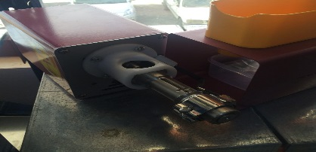 |  | Irbid Governorate
 | Herbs grinder machine | 1 | - New machine, equipped with a temperature controller, so temperature does not rise and burn the herbs  مطحنة قهوه وأعشاب تعمل على طحن الحبوب والاعشاب دون رفع درجة حرارتها او حرقها |  |  | Irbid Governorate
 | Stainless Steel Liquid Distillation Unit machine | 1 | - New machine to extract rose water and other similar liquids  ماكينة ستاينلس ستيل لفصل السوائل |  |  | Irbid Governorate
 | Bubble bath balls machine | 1 | - New machine to produce 3 different sizes of bubble bath balls  صناعة طابات فوارة للاستحمام بثلاث احجام | 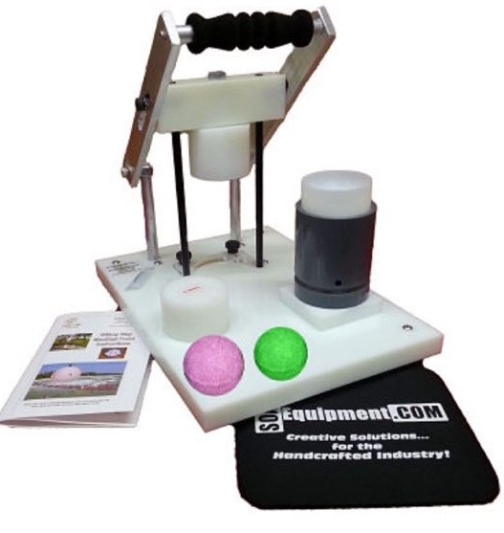 |  | Irbid Governorate
 | Wax melting machine | 1 | - New machine with faucet, 35-liter capacity, Stainless steel material  ماكينة ستاينلس ستيل سعة 35 لتر لصهر الشمع |  |  | Irbid Governorate
 | Vacuum packaging machine | 1 | - New small sized machine to package 50 candles per day  - Compatible to package all sizes of candles  - Not heat dependent  ماكينة تغليف للشمع |  |  | Irbid Governorate
 | Candles printer machine | 1 | - New printer with capacity to print on all candle sizes, equipped with additional toner  - Toner needs to be easily available in the market (please demonstrate availability in market)  - The printer should have connectivity abilities to PC/Laptop/Smart phone to extract pictures.  ماكينة طباعة على الشمع |  |  | Irbid Governorate
 | Mug hot stamping machine | 1 | - New printer with capacity to print on all mug sizes, equipped with additional toner  - Toner needs to be easily available in the market (please demonstrate availability in market)  - The printer should have connectivity abilities to PC/Laptop/Smart phone to extract pictures.  كابسة أكواب |  |  | Irbid Governorate
Equipment
 | Measurement scale - Large | 1 | - Large size measurement scale - up to 300 kilograms to weigh fluids (oils, water)  ميزان اوزان كبيرة للسوائل، ميزان دقيق جدا للأوزان الكبيرة من 300 كيلو فما فوق |  |  | Irbid Governorate
 | Measurement scale - Small | 1 | - Small size measurement scale – for light items under 5 kilograms to weigh essential oils, powders and fragrance  ميزان اوزان صغيرة، ميزان دقيق جدا للأوزان الصغيرة تحت 5 كيلو | 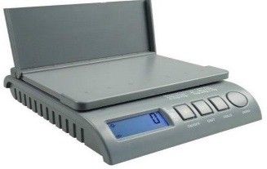 |  | Irbid Governorate
 | Soap cutter | 1 | - Wooden cutter with steel wires cutter  - Cuts 16 rectangular shapes  - Cuts soap in equal sizes, the size of each is 6cm*8cm, and of 2 cm thickness  اداة تقطيع صابون مصنوعة من الخشب ذات خيط فولاذ |  |  | Irbid Governorate
 | Wooden cutter – Rectangular - Soap | 2 | - Rectangular shape cutter, with a set of steel wires of 50cm height  - Produces 25 pieces, the size of each is 6cm*8cm, and of 2 cm thickness  اداة تقطيع تفصيل من الخشب طولها 50 سم . تنتج 25 قطعة , سماكة القطعة الواحدة 2 سم. يستخدم فيها اسلاك فولاذ | 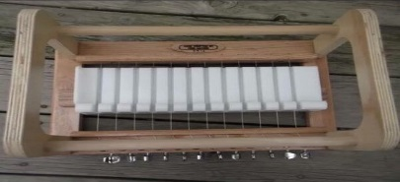 |  | Irbid Governorate
 | Wooden cutter – Circle - Soap | 1 | - Wooden Circular shape cutter, with steel wires  اداة تقطيع من الخشب واسلاك الفولاذ كما هي في الصورة |  |  | Irbid Governorate
 | Soap cutter - Large | 1 | - Large size soap cutter with steel wires  - Rectangular outer frame including 8 rectangular shapes  - Produces 8 blocks of soaps, the size of each is 6cm*8cm, and of 2 cm thickness  اله تقطيع قالب الصابون الكبير, تحتوي على اسلاك فولاذية , تقوم بانتاج 8 مكعبات من الصابون مقاس القالب الواحد 8*6 سم | 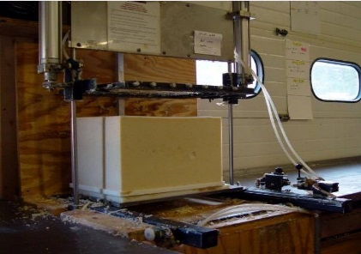 |  | Irbid Governorate
 | Mixer for Soap | 1 | - Multi-speed soap mixer with a tall handle, 1000 RPM, 2000 WAT  خلاط متحرك بعدة سرعات , الف دورة , ساق طويلة , 2000 واط , خاص بالصابون | 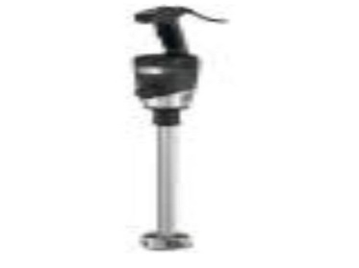 |  | Irbid Governorate
 | Mixer – Small - Soap | 1 | - Stainless Steel mixer with four legs and tap in the middle  - Capacity up to 50 liters’ capacity  - 220 Volts power  خلاط ستيل سعة 50 لتر مع ماتور 220 فولت, يفتح بابه نصف فتحة ,4 ارجل مع حنفية في الاسفل |  |  | Irbid Governorate
 | Mixer – Large - Soap | 1 | - Stainless Steel mixer with four legs and tap in the middle  - Capacity 150 liters  - 220 Volts power  خلاط ستيل سعة 150 لتر مع ماتور 220 فولت, يفتح بابه نصف فتحة ,4 ارجل مع حنفية في الاسفل |  |  | Irbid Governorate
 | Double jacket mixer - Soap | 1 | - Stainless Steel Mixer  - Capacity 200 liters  - 46 circles/minutes,  - Equipped with internal water heater and thermostat  خلاط ستيل دبل جاكت 200 لتر سخانات مائية داخليه معدل الدوران 46 لفة بالدقيقة , يمكن تعليته من الجهاز التحكم الالي للخلاط |  |  | Irbid Governorate
 | Double jacket mixer of 50 liters’ capacity - Candle | 1 | - Stainless Steel Mixer  - Capacity 50 liters  - 20-40 round/minute  - Equipped with a thermostat and a water heater |  |  | Irbid Governorate
 | Double jacket mixer of 150 liters’ capacity - Soap | 1 | - Stainless Steel Mixer  - Capacity 150 liters  - 220 Volts power  - Includes stands to hold the pot upright, with a door that opens on the tank side and tap in the bottom of the tank  خلاط ستيل دبل جاكت سعة 150 لتر , مع ماتور 220 فولت, يفتح بابه نصف فتحة ,4 ارجل مع حنفية في الاسفل | 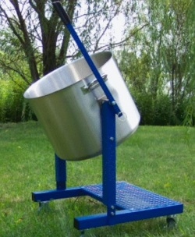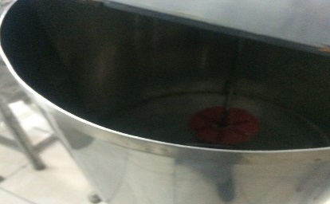 |  | Irbid Governorate
 | Container - liquids | 1 | - Stainless Steel container  - Capacity 50 liters  - Tap located in the bottom  Used for storing liquids  حافظة للسوائل ستاينلس ستيل بسعة 50 لتر مع حنفية في الاسفل |  |  | Irbid Governorate
 | Wax dipping tank | 1 | - 6 chambers, used to make candles.  - Each chamber to contain 5 liters, square shape, outer box is wooden and contains stainless steel liner  خزان لغمس الشمع |  |  | Irbid Governorate
 | Moveable shelves | 2 | - Wooden stand with four wheels, size 50*50cm to move the wooden molds, used to dry the soap  - سيبة عمل – رف عدد 16 زوايا ستيل – رفوف متحركة خشب لاتيه  - رفوف معدنية ارتفاع مترين مقاس 40*90 , ذات رفوف خشبية متحركة قابلة للاخراج والادخال بانتظام , المسافة بين كل رف والاخر 15 سم, ذات عجلات متينة  - منصب خشبي له 4 عجلات مقاس 50*50 سم لسهولة تحريك قالب الخشب | 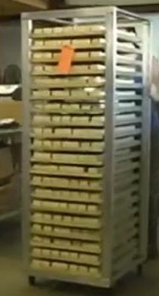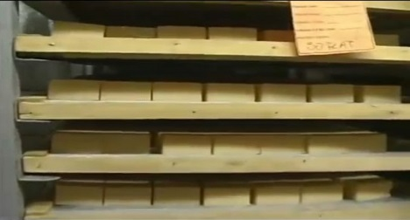 |  | Irbid Governorate
 | Temperature sensor | 2 | - Soap thermometer  ميزان لقياس حرارة الصابون | 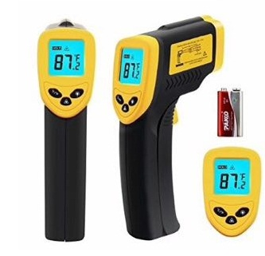 |  | Irbid Governorate

ANNEX III – Technical Proposal “RFQ# 08212016-0800 Machinery & Equipment for Candle Shop”
Details of the specifications proposed need to be filled out in the following table.

NO.  الرقم | Description  الوصف | Qty.  العدد | Proposed Specifications (Material, Capacity, Included Accessories, Power)  المواصفات المقترحة | Item currently available in Stock in Jordan  Y/N  هل السلعة متوافرة حاليا في الاردن  نعم\لا  If No, Specify Country to be Imported From  اذا الاجابة لا، الرجاء تحديد الدولة التي سيتم الاستيراد منها | Number of Calendar Days to Availability for Installation/Delivery  عدد الأيام لتسليم أو تركيب السلع | Warranty Offered  Y/N  And Period of Warranty  هل يوجد وكالة للسلع؟ يرجى تحديد مدتها
 | Example | 2 | Proposing 220V, 50Hz, 5-liter capacity, stainless steel | Yes | 20 | Yes - Three year
Machinery
1 | Oil extraction machine | 1
2 | Herbs grinder machine | 1
3 | Stainless Steel Liquid Distillation Unit machine | 1
4 | Bubble bath balls machine | 1
5 | Wax melting machine | 1
6 | Vacuum packaging machine | 1
7 | Candles printer machine | 1
8 | Mug hot stamping machine  كابسة أكواب | 1
9 | Measurement scale - Large | 1
10 | Measurement scale - Small | 1
11 | Soap cutter | 1
12 | Wooden cutter – Rectangular - Soap | 2
13 | Wooden cutter – Circle - Soap | 1
14 | Soap cutter - Large | 1
15 | Mixer for Soap | 1
16 | Mixer – Small - Soap | 1
17 | Mixer – Large - Soap | 1
18 | Double jacket mixer - Soap | 1
19 | Double jacket mixer of 50 liters’ capacity - Candle | 1
20 | Double jacket mixer of 150 liters’ capacity - Soap | 1
21 | Container - liquids | 1
22 | Wax dipping tank | 1
23 | Moveable shelves | 2
24 | Temperature sensor | 2
ANNEX IV – Cost Proposal “RFQ# 08212016-0800 Machinery & Equipment for Candle Shop””
Cost details for each item proposed should be filed out in the table below.

Number  الرقم | Description  الوصف | Quantity  العدد | Unit Price  JOD  سعر الوحدة بالدينار الأردني | Total Price  JOD  السعر الاجمالي بالدينار الأردني
1 | Oil extraction machine | 1
2 | Herbs grinder machine | 1
3 | Stainless Steel Liquid Distillation Unit machine | 1
4 | Bubble bath balls machine | 1
5 | Wax melting machine | 1
6 | Vacuum packaging machine | 1
7 | Candles printer machine | 1
8 | Mug hot stamping machine  كابسة أكواب | 1
9 | Measurement scale - Large | 1
10 | Measurement scale - Small | 1
11 | Soap cutter | 1
12 | Wooden cutter – Rectangular - Soap | 2
13 | Wooden cutter – Circle - Soap | 1
14 | Soap cutter - Large | 1
15 | Mixer for Soap | 1
16 | Mixer – Small - Soap | 1
17 | Mixer – Large - Soap | 1
18 | Double jacket mixer - Soap | 1
19 | Double jacket mixer of 50 liters’ capacity - Candle | 1
20 | Double jacket mixer of 150 liters’ capacity - Soap | 1
21 | Container - liquids | 1
22 | Wax dipping tank | 1
23 | Moveable shelves | 2
24 | Temperature sensor | 2
Other Costs (Delivery and Installation)  أجور إضافية (توصيل وتركيب) |  |  | JOD
GRAND TOTAL (excluding Sales & Customs Tax)  الإجمالي من دون ضريبة المبيعات والجمارك |  |  | JOD

